Title (Times New Roman size 14, bold)

First Author, AffiliationTimes New Roman 10 pt bold (centered)
Email 1@daneshpajoohan.ac.ir Times New Roman 10 pt
Second Author, Affiliation Times New Roman 10 pt bold (centered)
Email 2@daneshpajoohan.ac.ir
Third Author, Affiliation and others
Email 3@daneshpajoohan.ac.ir

Abstract
The abstract must be limited between 150 to 200 words. The abstract should clearly state, the objective, research methods, results and the conclusion of the research.
Keywords
Between 3 to 7 keywords separated by “,”

Introduction
The manuscript must not exceed 12 pages. Please use the following guidelines in Materials and Methods and prepare your full manuscripts. If manuscripts are not prepared according to the following guidelines they will be withdrawn from the conference program.

Materials and Methods
The basic elements of a manuscript are listed below in the order in which they should appear:
- Conference header
- Manuscript title
- Author names and affiliations
- Abstract
- Keywords
- Introduction
- Materials and Methods
- Results and Discussion
- Conclusions
- Acknowledgment
- References
- Appendices
Manuscript Preparation
All manuscripts must be written in either English or Persian (Farsi). Manuscript will be presented in the language that it is written in.
Manuscript must be sent by uploading in the conference website. Don’t use Email for sending manuscripts.
For English manuscripts; the fonts for all parts of the manuscript is Times New Roman as follows:
- Title: 12 pt bold (centered)
- Author(s): 10 pt bold (centered)
- Affiliations: 10 pt (centered, italic)
- Keywords: 10 pt
- Section Headings: 11 pt bold
- Subsection Headings: 10 pt -Others: 10 pt
Manuscripts must be prepared using Word 2003 or higher. They must be submitted in both PDF format and a word file. Each A4 page is margined 2.54 cm (1 inch) all-round.
The headings will start from the far left. Use single spacing with no space between the section headings and the paragraph following it. Put one space between the texts of main sections. Manuscript must have page numbers.
System of Units
SI unit system should be applied. If necessary, use the equivalent value in the other system of units in brackets after the SI system of units.
Equations
Equations start from the far left of the column and numbered consecutively. The equation number must be bracketed and placed opposite to the equation on the far right of the line in that column.

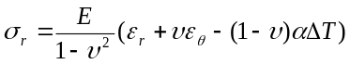 (1)
Tables, Figures and Photographs

Tables must be numbered and the title of the table must be placed on the top of the table with the footnotes on the bottom. Tables must appear where (or as close as) they are first mentioned in the text. They must be referred in the text as "Table (1)".
Figures must be numbered and the caption of the figure must come at the bottom of the figure. All the legends and the numerical values on the axes of the curves must be clear and readable. Figures must appear where (or as close as to) they are first mentioned in the text. They must be referred in the text as "Figure 1".
Photographs must be original and follow above instruction for numbering and captions. Leave one space between the Table/Figure and the text following it.
Table (1). Major cities on the 21 routes to London
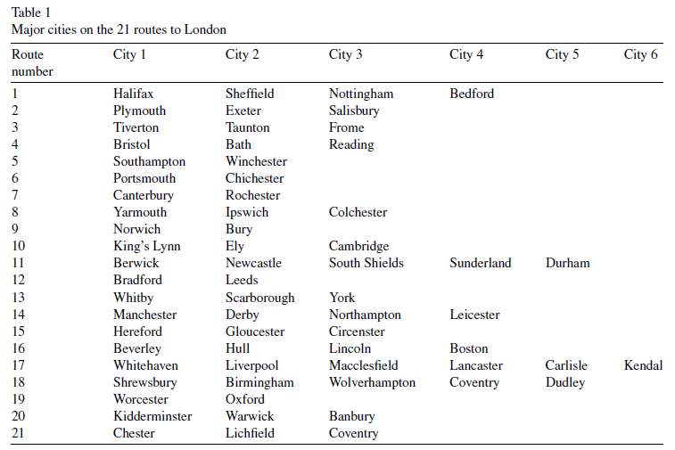

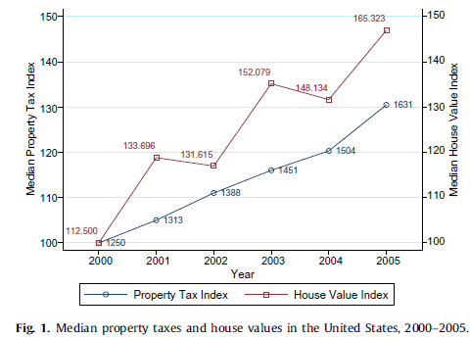

Figure (1). Median property taxes and house values in the united states, 2000-2005

Results Discussion
All achieved results should be carefully investigated and compared with the other works.
Conclusions
Main conclusions of the manuscript must be put here.
List of Symbols
The list of symbols comes after the acknowledgment and before references, if it is required. The English symbols come first followed by the Greek symbols. Both must be typed in alphabetical order and separated.
References
The references should be in alphabetical order. The Ref Listing style will create the indents. Press Enter for the next entry. Compose your reference entries following the examples below. We encourage you to

use the reference management system in MSWord. Choose APA style (7th ed.). You may also use EndNote or any reference manager system that displays in Word.
The references in the manuscript text
Examples!
Journal Article
Lastname, A. B., Author, C. D., & Jones, E. (2014). Title of journal article. Applied Eng. Agric., 78(12),5-10. http://dx.doi.org/10.1234/14x.567

Book
Author, A. B. (2014). Book Title. City, State, Nation if not US: Publisher.

Part of a Book
Author, A. , Twoauthor, B. C. (1987). Section or chapter title. In Book Title, (pp. 17-34). City, State: Publisher.

Chapterauthor, A. (1987). Section or chapter title. In B. Bookeditor (Ed.), Book Title, (pp. 17-34).City, State, Nation if not US: Publisher.

Standard
ASABE Standards. (2008). S358.2: Moisture measurement—Forages. St. Joseph, Mich.: ASABE.
ABCD. (2014) 12343: Standard name. City, State: ABCD (spell out if unfamiliar).

Bulletin or Report
Bulletins, reports, and other small, self-contained documents often do not have named authors. For the purpose of citing the document in your manuscript, use the name of the publishing organization as the author, abbreviated if necessary. Do not use “Anonymous.”
ABCC. (2004). Report title. X1234. City, State, Nation if not US : ABC Commission. Retrieved from www.abcc.gov/x1234.pdf

Paper from a Meeting
Author, A. B., & Name, C. D. (2014a). Title of paper. ASABE Paper No. 1401234. St. Joseph, Mich.: ASABE.
Author, A. B., & Name, C. D. (2014b). Title of paper. In Proc. 10th Intl. Conf. Agricultural Engineering (pp. 55-66). St. Joseph, Mich.: ASABE.

Software
An author’s name is rarely available for software products, so the reference is usually alphabetized (and cited in the text) with a shortened version of the company name or product name.
SAS. 1990. SAS User’s Guide: Statistics. Ver. 6a. Cary, N.C.: SAS Institute, Inc.

Online Source
BCD. (2014).Title. BioCropsDiversity. Retrieved from http://bcd.org/report.pdf
Dissertation or Thesis
Author, A. (2014). Title of dissertation. PhD diss.[or MS thesis.]City, State, Nation if not US: University Name, Department of Engineering.

Patent
Author, A. B. 2014. Patent title. U.S. Patent No. 123456.
Nomenclature (delete if unused)

Appendix (delete if unused)

Artificial Intelligence Use Declaration
Was artificial intelligence (AI) or generative AI used in the preparation of this paper?
☐ No
☐ Yes
If “Yes,” please describe the type and manner of use of the AI tool(s):
Tool/System Name: …………………
How It Was Used: …………………
Section(s) of the Paper Where It Was Used: …………………

1-Corresponding Author

